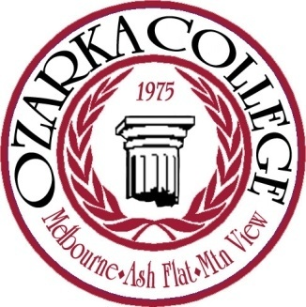

Instructional Council Agenda
January 06, 2009

- Call to Order 8:30 am

- Additions to the agenda

- Approval of last meeting minutes

- Gen Ed Outcomes (Michael Orf)

- Catalog

- Adjunct Faculty Orientation

- Administrative Council Update

- Roundtable

- Adjourn

