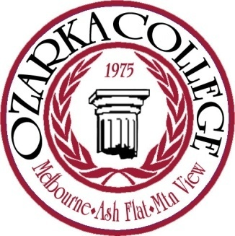

Instructional Council Agenda
January 22, 2009

- Call to Order 8:30 am

- Additions to the agenda

- Approval of last meeting minutes

- Gen Ed Outcomes (Michael Orf…update)

- Catalog

- Upcoming Assessment Workshop (New date: Feb. 12-13)

- Software and equipment purchases

- Professional Reviews

- Administrative Council Update

- Roundtable

- Adjourn

