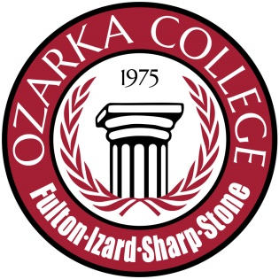

### Date:

### December 2, 2014

### Time: 2:00 pm

### Place of Meeting: President's Conference Room

## AGENDA

* Call to Order
* Review of new/modified programs
  + Associate of Applied Science in Culinary Arts
  + Associate of Science in Education
  + Certificate of Proficiency in Information Science Technology
  + Technical Certificate in Information Science Technology
* Discussion
* Adjournment

# Ozarka Board of Trustees

Academic Affairs Committee