LETTER OF NOTIFICATION – 5

DELETION
(Certificate, Degree, Option, Organizational Unit)

- Institution submitting request: Ozarka College

- Contact person/title: Dr. Mike DeLong

- Phone number/e-mail address: 870-368-2004/mdelong@ozarka.edu

- Proposed effective date: February 2011

- Title of certificate, degree program, option, or organizational unit: AAS in Criminal Justice Leadership

- CIP Code: 43.0103

- Degree Code: 0385

- Reason for deletion: Low activity program. Has not graduated an acceptable number of graduates for viability

- Number of students still enrolled in program: 2

- Expected graduation date of last student: May 2012

- Name of courses which will be deleted as a result of this action:

6 or more hours from CJL Courses
  - CJL 1013 Principles of Criminal Justice Leadership
  - CJL 1213 Agency Management
  - CJL 1323 Essential Communication for Criminal Justice Professionals

At least 6 hours for law enforcement officers
- CJL 2013 Criminal Investigation Management
- CJL 2023 Criminal Evidence Management
- CJL 2033 Community Policing Management

At least 6 hours for corrections officers
- CJL 2053 Corrections Supervision
- CJL 2063 Correctional Facility Management
- CJL 2073 Offender Management

- How will students in the deleted program be accommodated: Class will be offered until students graduate, change major, or drop

- Are funds available for reallocation? N/A

Board of Trustees Approval Date: December 16, 2010

Chief Academic Officer: 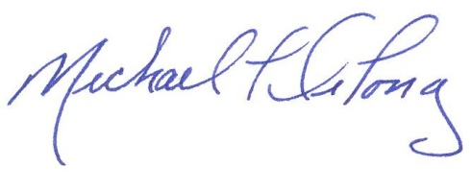 Date: December 2, 2010

