LETTER OF NOTIFICATION – 5

DELETION
(Certificate, Degree, Option, Organizational Unit)

- Institution submitting request: Ozarka College

- Contact person/title: Dr. Mike DeLong

- Phone number/e-mail address: 870-368-2004/mdelong@ozarka.edu

- Proposed effective date: February 2011

- Title of certificate, degree program, option, or organizational unit: AAS in Physical Therapy Assistant

- CIP Code: 51.0806

- Degree Code: 0750

- Reason for deletion: Inactive for over 5 years

- Number of students still enrolled in program: 0

- Expected graduation date of last student: N/A

- Name of courses which will be deleted as a result of this action:

- PTA 1204 Kinesiology
- PTA 1304 Applied Basic Theory for PTAs I
- PTA 1404 Physical Therapy Procedures for Assistants I
- PTA 1504 Applied Basic Theory for PTAs II
- PTA 1603 Clinical Practicum I
- PTA 2104 Physical Therapy Procedures for Assistants II
- PTA 2204 Neurophys. and Rehab. Techniques for PTAs
- PTA 2303 Principles of Admin. and Management for PTAs
- PTA 2403 Clinical Practicum II
- PTA 2503 Clinical Practicum III

- How will students in the deleted program be accommodated: N/A

- Are funds available for reallocation? N/A

Board of Trustees Approval Date: December 16, 2010

Chief Academic Officer: 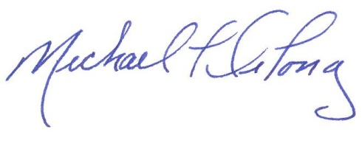 Date: December 2, 2010

