LETTER OF NOTIFICATION – 5

DELETION
(Certificate, Degree, Option, Organizational Unit)

- Institution submitting request: Ozarka College

- Contact person/title: Dr. Mike DeLong

- Phone number/e-mail address: 870-368-2004/mdelong@ozarka.edu

- Proposed effective date: February 2011

- Title of certificate, degree program, option, or organizational unit: Certificate of Proficiency in Over-the-Road Trucking

- CIP Code: 49.0205

- Degree Code: 4895

- Reason for deletion: Inactive for over 5 years

- Number of students still enrolled in program: 0

- Expected graduation date of last student: N/A

- Name of courses which will be deleted as a result of this action:

  - ORT 1004 Over the Road Trucking
  - ORT 1014 Over the Road Trucking Practicum

- How will students in the deleted program be accommodated: N/A

- Are funds available for reallocation? N/A

Board of Trustees Approval Date: December 16, 2010

Chief Academic Officer: 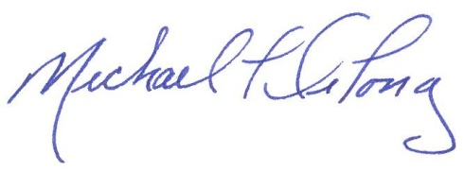 Date: December 2, 2010

